EXAMPLE SCREENSHOTS

1) with few shot approach

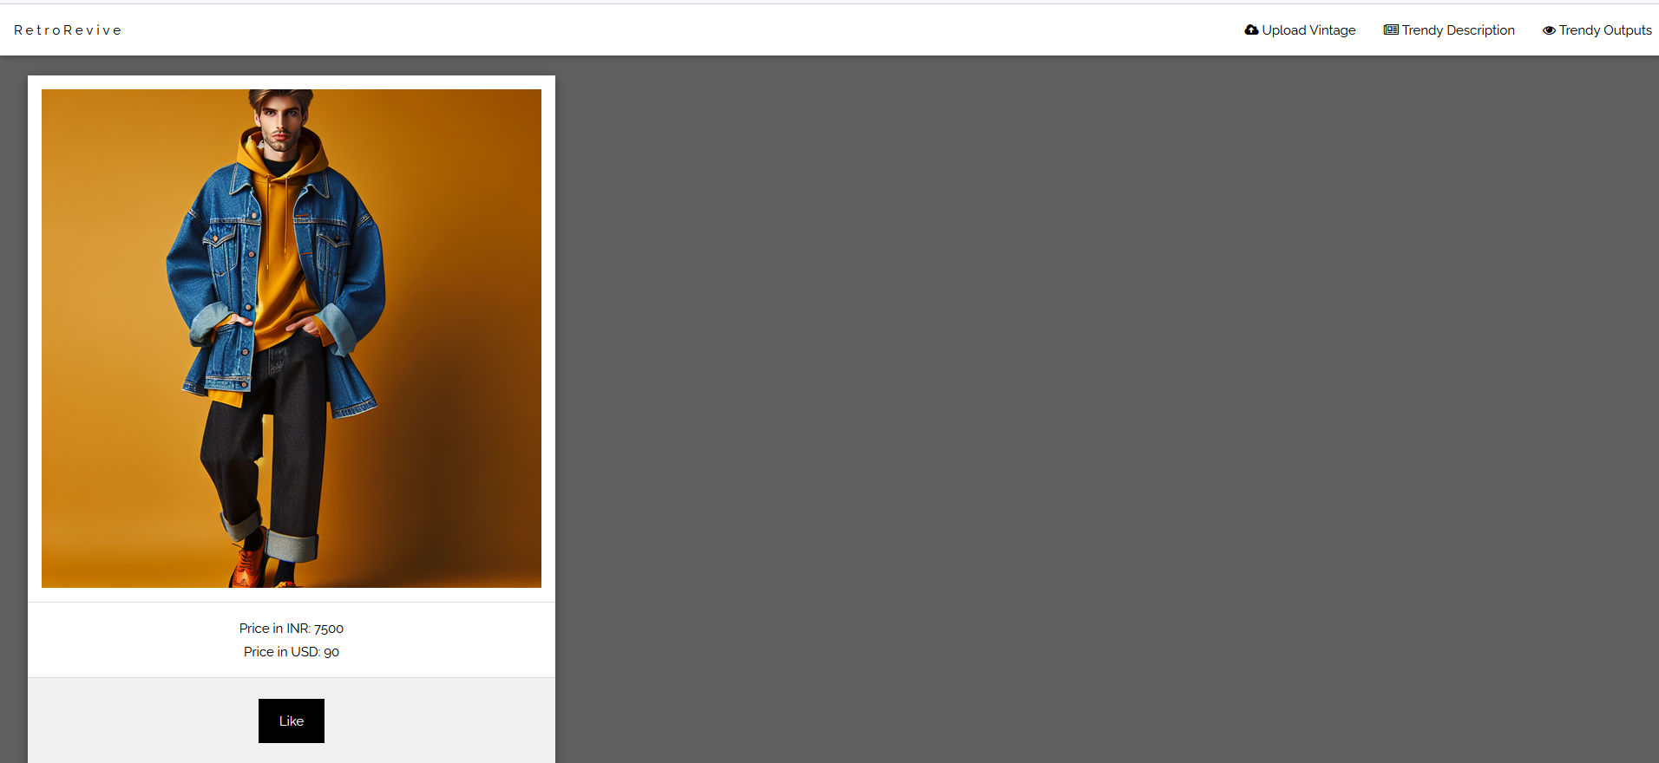

Without few shot approach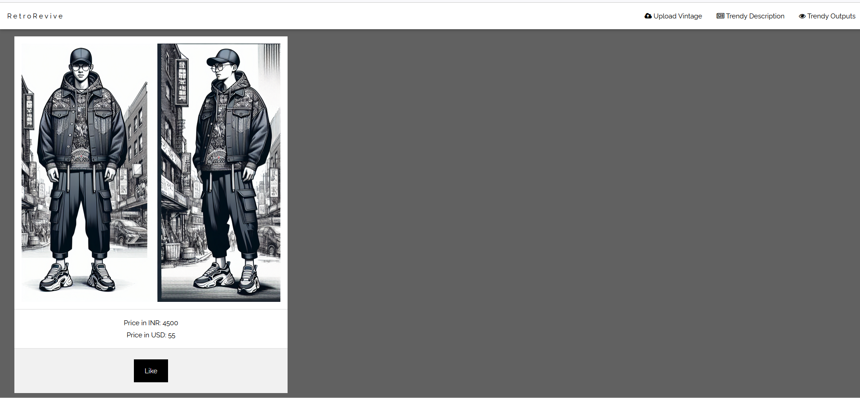

2)With few shot approach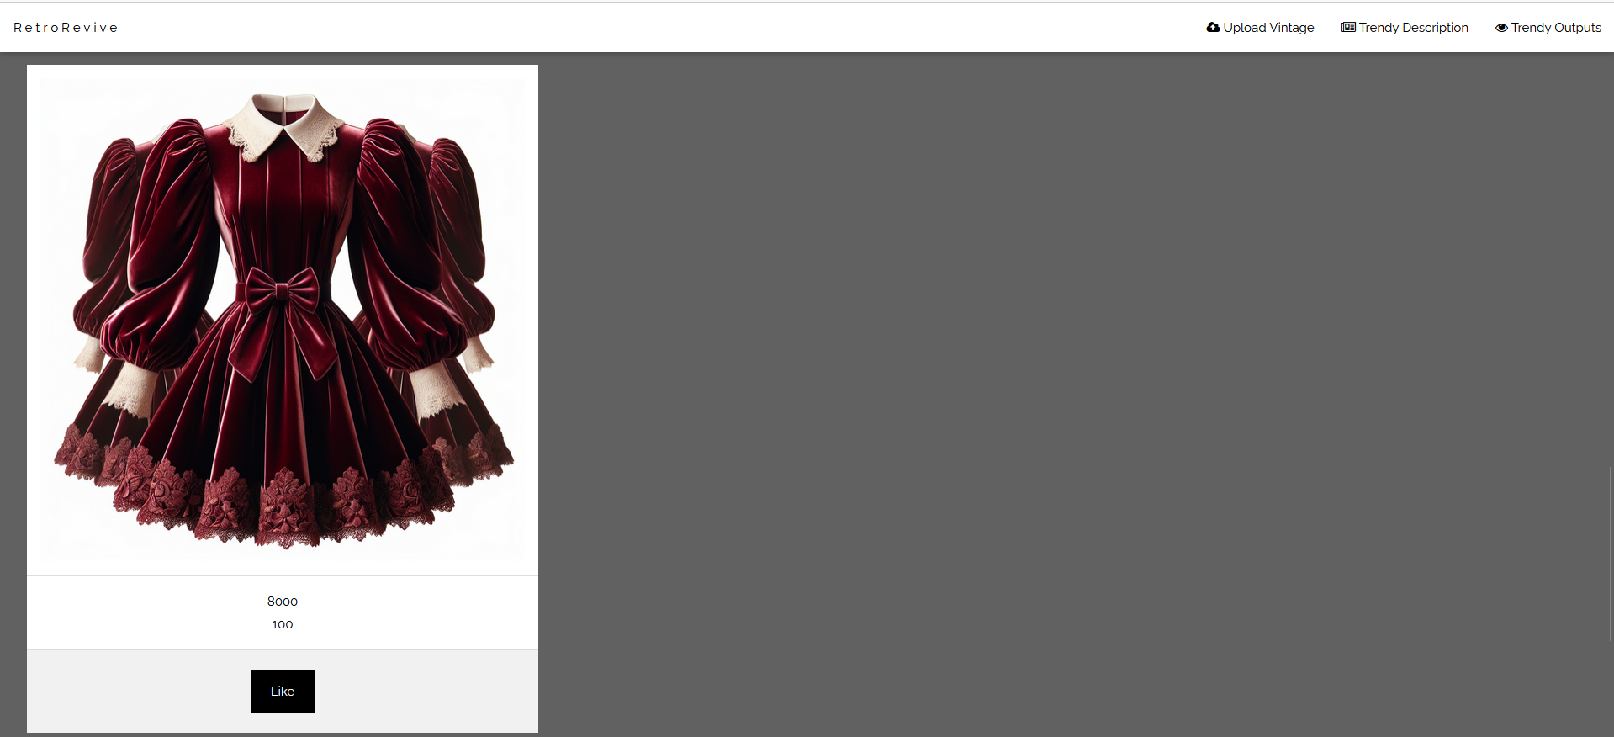

WITHOUT FEW SHOT APPROACH

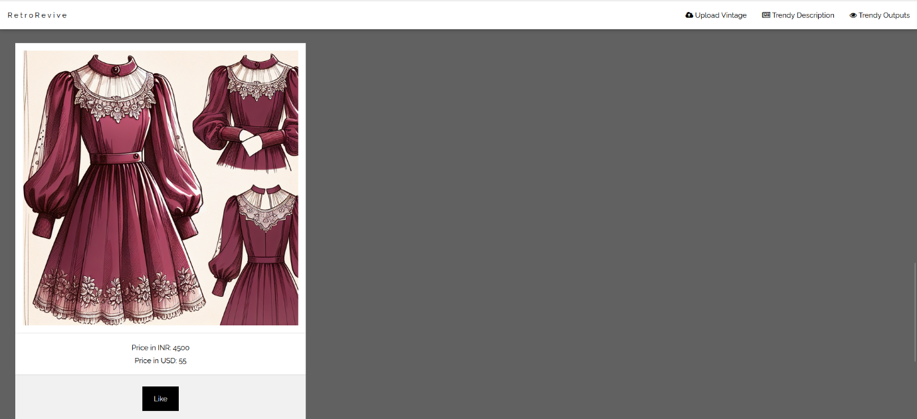

3) WITH FEW SHOT APPROACH

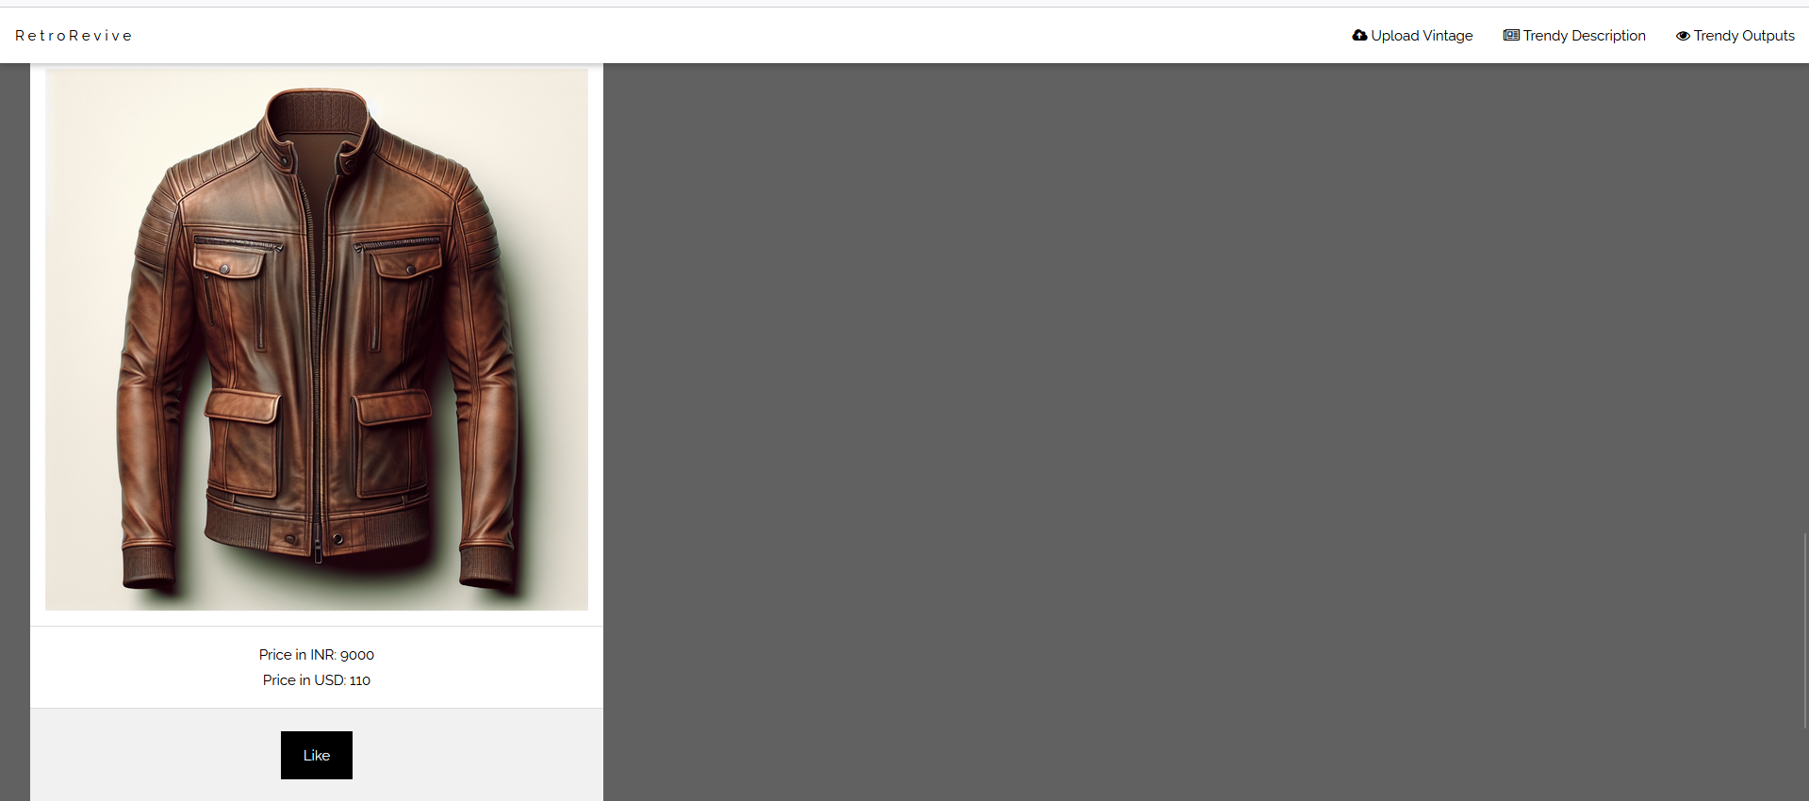

WITHOUT FEW SHOT APPROACH

